Information on overload wheelbase

The tables on overload wheelbase indicate the equal distributed load for different distances between two or more braces. The values published in the load bearing capacity table are the result of calculation simulations based on the performance of ISOPAN group's sandwich roofing panels.

Example: According to load-span table an ISOBOX 2.5’’ in 24/26 gauge in a single span of 7’ 5/8” (215 cm) offers an equal distributed load of 40.96 PSF (250 Kg/smq). This means, that in for the same thickness, with a smaller distance between axes the distributed load increases, and for the same distributed load, a greater thickness represents greater distances.

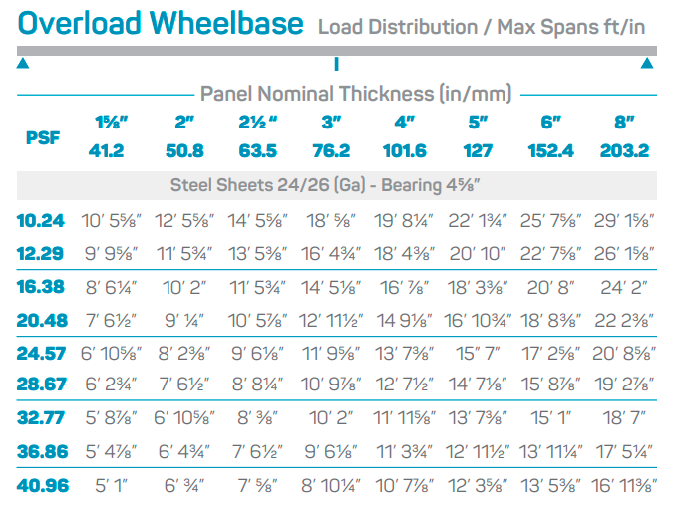

*This logic applies to the table of two and more spans*

